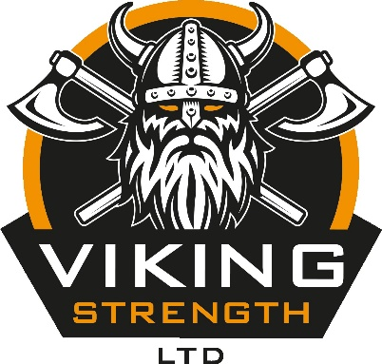

VIKING STRENGTH RAW POWERLIFTING
COMPETITION RULES DOCUMENT

WEIGHT CLASSES

This competition is available for both male and female competitors, with the following weight categories available to enter:

Female

Under 60kg
60.01kg - 75kg
75.01kg - 90kg
90.01kg - 105kg
105.01kg+

Male

Under 80kg
80.01kg - 95kg
95.01kg - 110kg
110.01kg - 125kg
125.01kg+

AWARDS

There will be a winner for each weight category across both the male and female classes, as well as an award for 1st, 2nd and 3rd place overall based on the Wilks score, with both a female and male podium at the end of the day.

That’s a potential 16 awards being awarded at the end of the day!

These are huge competitions with plenty of spectators making noise to support each and every lifter.

SCHEDULE

Weigh-in and registration is 08.00 – 09.00

Flight one will lift off at 10.00.

There will be three flights on the day, which will follow on from one another back-to-back, with a small break between squat and bench, with another break between bench and deadlift.

We will confirm the schedule in more detail when we have an idea of how many competitors will be in each class

BASIC COMPETITION RULES

Wearing a Powerlifting singlet is allowed but not mandatory for all three events.

THE SQUAT IS FIRST

We will be using a Rogue Ohio Power Bar and a combo rack.

After removing the bar from the rack and establishing the starting position, you must wait for the "Squat" command. Sit into the squat and return to the starting position. Once there, wait for the "Rack" command before returning the bar to the rack.

Tight clothing and a T-shirt must be worn. A lifting belt, 7mm Neoprene knee sleeves, wrist wraps and a singlet are all allowed but not mandatory.

Failure to return to the starting position unassisted, or any downward movement of the bar will result in a no lift. Failing to reach proper depth (where the crease of the hip is in line with, or below, the top of the knee) will result in a “no lift”

Three attempts will be taken and the highest completed squat will be added to your total.

We will be allowing the "Talon Grip".
​
THE BENCH PRESS IS SECOND

We will be using the Rogue Ohio Power Bar and a combo rack.

After removing the bar from the rack and establishing the starting position, you must wait for the "Start" command. Lower the bar to the chest and wait for the "Press" command, before pressing the bar and returning to the starting position. Once there, wait for the "Rack" command before returning the bar to the rack.

Tight clothing and a T-shirt must be worn. A lifting belt, wrist wraps and a singlet are all allowed but not mandatory. Elbow sleeves or any other elbow support are not allowed.

Failure to lock out the elbows, the buttocks coming off the bench or any downward movement of the bar during the ascent will result in a no lift.

Three attempts will be taken and the highest completed Bench Press will be added to your total.

We are allowing the heels to be raised and the head to be lifted off the bench, providing that no other rules are broken by doing so.

FINALLY, IT’S THE DEADLIFT

We will be using the Rogue Ohio Power Bar.

After approaching the bar, pick the weight up and stand with the knees and hips locked with the shoulders back. Once locked out, you must wait for the "Down" command before placing the bar back on the floor, without dropping it or inappropriately slamming it back down.

Tight clothing must be worn and the shins must be covered.

Footwear must be worn during the Deadlift event (we won’t allow socks only).

Chalk, talc, a lifting belt and singlet are allowed but not mandatory.

Failure to lockout the Deadlift or hitching/ramping will result in a no lift.

Three attempts will be taken and the highest completed Deadlift will be added to your total.

The highest completed total in each weight class wins!

