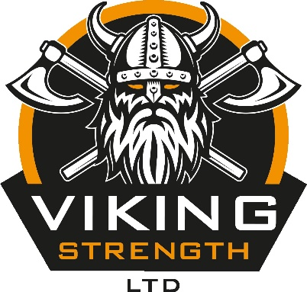

VIKING STRENGTH SQUAT ONLY COMPETITION
COMPETITION RULES DOCUMENT

WEIGHT CATEGORIES

This competition is available for both male and female competitors, with the following weight categories available to enter:

Female

-56kg
-60kg
-67.5kg
-75kg
-82.5kg
-90kg
90kg+

Male

-82.5kg
-90kg
-100kg
-110kg
-125kg
-140kg
140kg+

CLASSES

The classes available to enter are:

Traditional Raw – Knee sleeves (7mm Neoprene) or bare knees
Classic Raw – Knee Wraps or “Ply” knee sleeves
Single Ply
Multi Ply

AWARDS

There will be a podium (1st, 2nd and 3rd) for each weight category across both the male and female classes, as well as a male and female overall winner based on the Wilks score, for each class.

That’s a potential 16 awards being awarded at the end of the day!

These are huge competitions with plenty of spectators making noise to support each and every lifter.

SCHEDULE

Weigh-in and registration is 08.00 – 09.00

Flight one will lift off at 10.00.

There will be three flights on the day, which will follow on from one another back-to-back.

We will confirm the schedule in more detail when we have an idea of how many competitors will be in each class

BASIC COMPETITION RULES

Wearing a Powerlifting singlet is mandatory for this competition

THE SQUAT

We will be using a Texas Squat Bar and a Mono-rack.

After removing the bar from the rack and establishing the starting position, you must wait for the "Squat" command. Sit into the squat and return to the starting position. Once there, wait for the "Rack" command before returning the bar to the rack.

A singlet and cotton T-shirt must be worn. A lifting belt, and wrist wraps allowed but not mandatory for all classes

A multi-ply squat suit and knee wraps up to 3m are allowed for the multi-ply class

A single-ply squat suit and knee wraps up to 3m are allowed for the single-ply class

Knee wraps up to 3m or ply knee sleeves are allowed for the classic raw class

Bare knees or 7mm Neoprene knee sleeves are allowed for the traditional raw class

Failure to return to the starting position unassisted, or any downward movement of the bar will result in a no lift. Failing to reach proper depth (where the crease of the hip is in line with, or below, the top of the knee) will result in a “no lift”. Missing any of the commands will result in a “no lift”.

Three attempts will be taken and the highest completed squat will win each weight category/class

We will be allowing the "Talon Grip".
​

