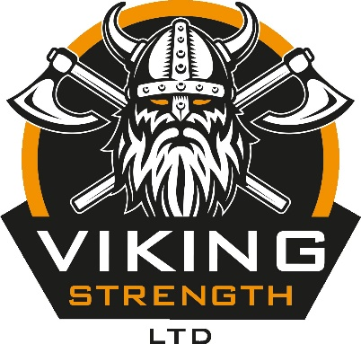

VIKING STRENGTH MAX DEADLIFT COMPETITION
COMPETITION RULES DOCUMENT

VENUE

Competitions are held right here at the gym, our address is:

Units 3 & 4 Enterprise Business Park
Mortimer Rise
Off Milner Way
Ossett
Wakefield
West Yorkshire
WF5 9JH

We have limited free parking spaces allocated just outside the gym and, once these have been taken, there is plenty of free on street parking on Mortimer Rise and Milner Way. Please be respectful of other businesses on the estate and refrain from parking in front of any other roller shutter doors. We have highlighted possible parking spaces in the photo below:
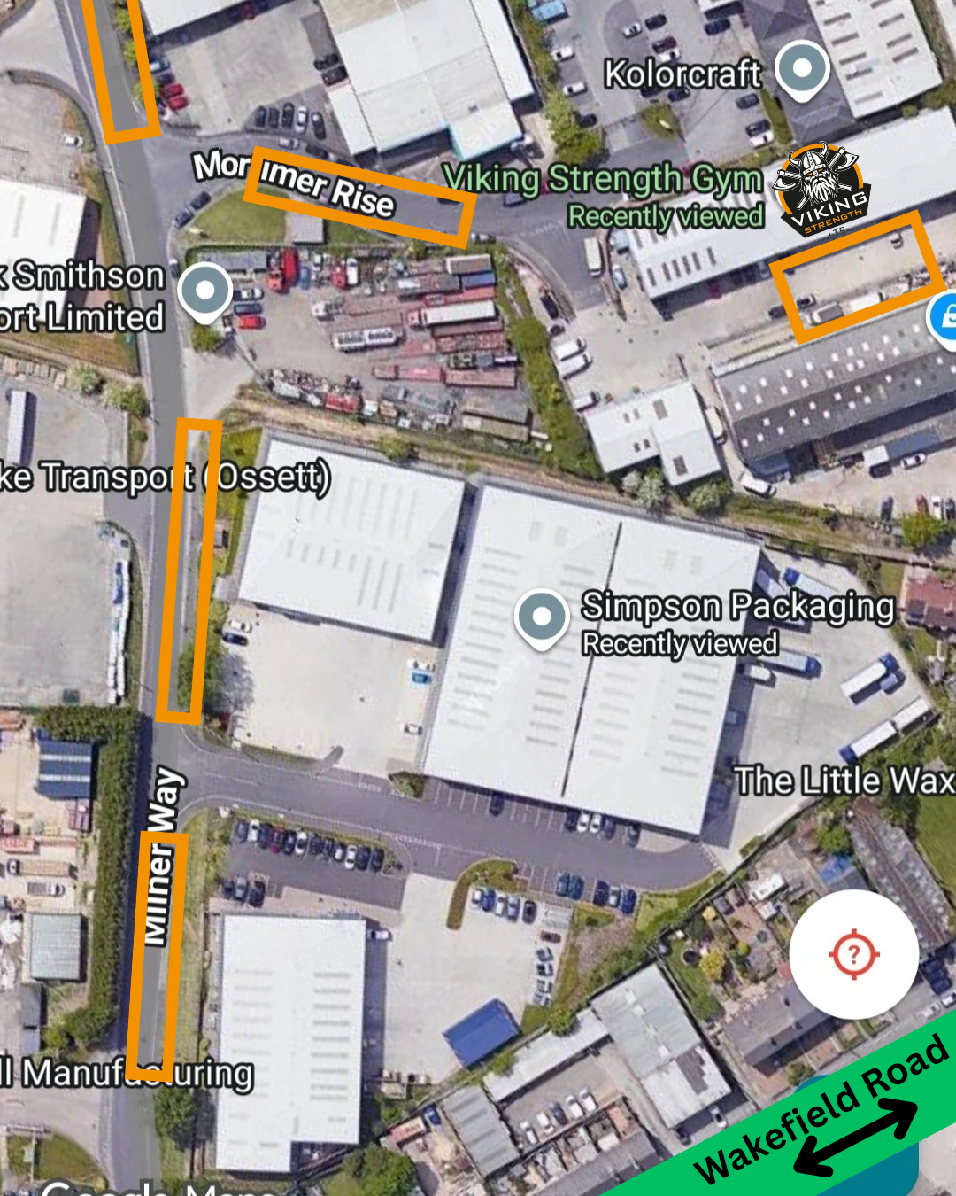

SCHEDULE

(Times subject to change slightly)

AM Competition:

8.00am - 9.00am: Registration and weigh-in for all female competitors
09.30am: Female Novice rising bar competition starts. Opening weight is 70kg
10.30am: Female Open rising bar competition starts. Opening weight is 120kg
11.30am: Female awards ceremony

PM Competition:

12.00pm - 1.00pm: Weigh in and registration for all male competitors
1.30pm: Male Novice rising bar competition starts. Opening weight is 140kg
2.30pm: Male Open rising bar competition starts. Opening weight is 220kg
3.30pm: Medal ceremony for all male competitors

RULES

Every athlete must attempt the opening weight for their category.

The weight will rise by 10kg per round.

An athlete has the option to 'skip' weights if they choose to.

We will make 5kg increments when we reach:
100kg in the female novice category
150kg in the female open category
200kg in the male novice category
300kg in the make open category

Once we are down to the last three athletes they can then make their own weight selections for their attempts.

Once you have missed an attempt at a weight you are out of the competition.

Biggest weight lifted is the overall winner with another winner for the best lb for lb deadlift on the day.

If the winner of the max overall award also has the best lb for lb deadlift, they will take home both medals.

You will be given 60 seconds to attempt the weight once you have stepped onto the platform.

Shins must be covered for the event and usual gym attire is acceptable for the competition. Usual clothing rules apply such as no outdoor footwear etc.

There will be one judge on the day. Athletes must wait for the "down" command from the judge and PUT THE WEIGHT DOWN to complete the lift.

Straps, chalk, talk, hitching and sumo is all allowed on the day, however, no suits please unless you are in an equipped class or a guest lifter.

